Order form. Eng 2015.
To be delivered at: DEALER: |  | COSTOMER:
Dealer: |  | Costomer:
Tel:
E mail:
VAT nr: |  | Mobile:

Date: |  | Number:
A | Fence itself . Please mention for each length the number of pieces required. | 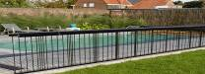 | 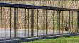
  Length (in cm): | Number:
B | Stainless steel channel. (Do not indicate measurements, we will use those listed above.)  Indicate your choice on the right by circling yes or  no. Always choose one of the two. | 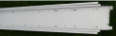 | Yes
B |  |  | No
C | T–piece for stainless steel built-in channel. | 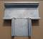 | ..
D | L-stuk o L-piece or corner piece for stainless steel built-in channel. | 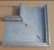 | ..
E | Hard anodizing : aluminium in colour.  Please indicate which colour you want, if any . | Black Red Green  Blue Purple
F | LED atmospheric colour lighting RGB. | 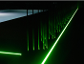  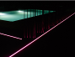  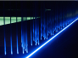
  Length (in cm): | Number:
G | Operating handle. 1 required per installation.  If you need more than 1, please indicate how many additional handles you want on the right. | 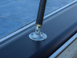 | ..
H | Child lock. 1 required per length of fencing. | 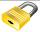 | ..
I | RGB controller.  Module de commande RGB. 350 W.  RGB-Steuerung.  RGB controller. | 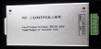 | ..
J | Handzender LED verlichting.  Télécommande pour éclairage LED.  Handsender Beleuchtung.  Hand-held transmitter LED lighting. |  | ..
K | Voeding waterproof.  Alimentation étanche.  Netzteil wasserdicht.  Waterproof power supply.  220 V AC – 12 V DC 350 W. | 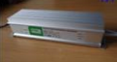 | ..
L | Versterker – amplifier.  Amplificateur . 350 W.  Verstärker – Amplifier.  Amplifier. | 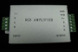 | ..
I, J, K en L: Option only in case of LED.
GB controller: 1 required per installation.
K & L: 1 m LED = 14 W. So for power supply and amplifier: max 24 m LED/each.
So per 24 metres 1 power supply and 1 amplifier
Amplifier: to be used starting from 24 metres.

This order complies with the technical specifications indicated by VVKprotect.
For more information about possible combinations, please refer to the sketches in the manual.

